
Mobile App for Disaster Alert and Management

Design Document

Version 1.0



Group Id: F19020601C (MC180403934)
Supervisor Name: Muhammad Anwar

Project domain / category
Mobile application

Revision History

Revision History

Date (dd/mm/yyyy) | Version | Description | Author
21 / 1 /2020 | 1.0 | Mobile App for Disaster Alert and Management | F19020601C (MC180403934)
This document is made to define requirements specifications of disaster management system.
This mobile Application will be developed by utilizing Android development IDE
Example: Android Studio, Eclipse for Java, xml.
 |  | This app also provide alert to rescue teams about the areas that need urgent relief. which can predict any natural disaster such as storms, earthquake, flood and other natural calamities.
 |  | If any event happen this app also provide an alert to the user so that he can move to the safe place to avoid the disaster. In case of disaster this app also provide alert to rescue teams about the areas that need urgent relief.

Table of Contents

- Introduction of Design Document
- Entity Relationship Diagram (ERD)
- Sequence Diagrams
- Architecture Design Diagram
- Class Diagram
- Database Design
- Interface Design
- Test Cases

Introduction of Design Document

This phase contains following data.

SRS document focus on “what to do” whereas design document focus on “how to do”. In the design phase the focus is shifted from ‘WHAT’ to ‘HOW’ means how the problem will be solved and which tools and techniques will be used. Design document maps the requirement gathered in SRS document into the components, their interfaces and behaviors. The purpose of design phase is to plan out a system that meets the requirement defined in the analysis phase. In the design phase, the project team finds out the project solution that how the product will be created. To do this, the project team uses the inputs and tools to conduct the key activities, create the outputs, and meet the milestones for this Design phase. It contains different diagrams and finally an architecture diagram which define the overall picture of project.

Design Document
Entity Relationship Diagram:

Entity Relationship Diagram is a data model for describing a database in an abstract model. It contains entities and their relationships. An entity may be defined as a thing which is recognized as being capable of an independent existence and which can be uniquely identified. An entity is an abstraction from the complexities of a domain.

An Entity–relationship model (ER model) describes the structure of a database with the help of a diagram, which is known as Entity Relationship Diagram (ER Diagram). An ER model is a design or blueprint of a database that can later be implemented as a database. The main components of E-R model are: entity set and relationship set.

What is an Entity Relationship Diagram (ER Diagram)?
An ER diagram shows the relationship among entity sets. An entity set is a group of similar entities and these entities can have attributes. In terms of DBMS, an entity is a table or attribute of a table in database, so by showing relationship among tables and their attributes, ER diagram shows the complete logical structure of a database.
Sequence Diagram:

Sequence Diagram is an interaction diagram that shows how processes operate with each other.
A sequence diagram shows interaction of diagram according to the time division. It is also called event diagram.

Architecture Design Diagram :

Architecture Design Diagram used to represent data in the form of layers .It contains three layers data link layer, application layer and business layer.

Class Diagram

Class Diagram in this design document describes the structure of catering stock system by showing the system's classes, their attributes, operations or methods and relationships between classes. The classes in a class diagram represent both the main objects and interactions in the applications and the objects to be programmed.

Database Design :

Database Design is a process of producing a detailed data model of a database. It can be taken as the logical design of the base data structures to store the data. In the relation model these are the tables and views.

Interface Design :

Interface Design is a GUI view of main software .It shows how our program will look like. Interface design deals with the process of developing a method for two (or more) modules in a system to connect and communicate.
Test cases :

Test cases for the catering stock System are also given. A test case in software engineering is a set of conditions or variables under which a tester will determine whether an application or software system is working correctly or not. It is a detailed procedure that fully tests a feature or an aspect of a feature.

Entity Relationship Diagram ERD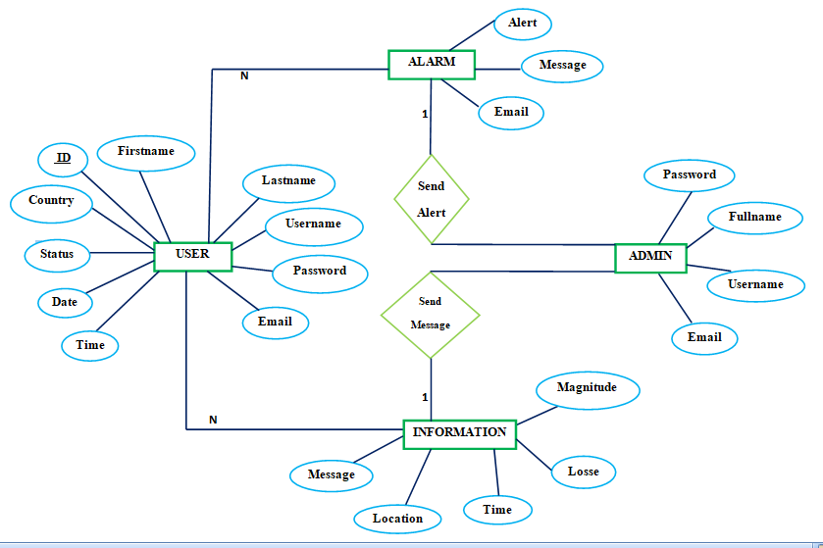

Sequence Diagrams
Registration to the app :
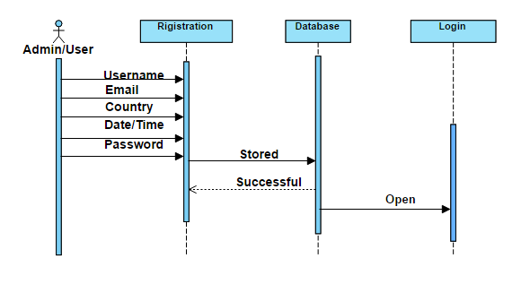

Sequence Diagrams

Login to the app :
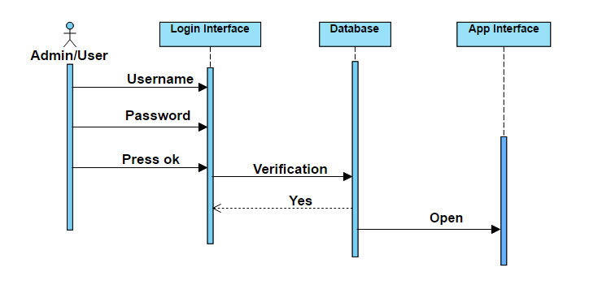

Sequence Diagrams
Select menu to predict the location:
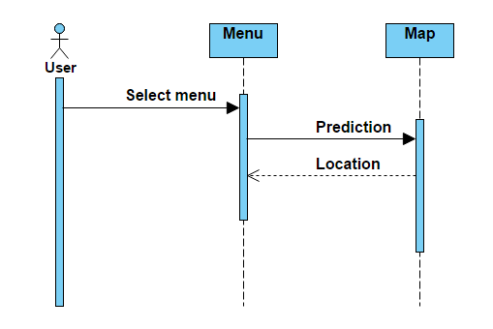

Sequence Diagrams
Message to alert:
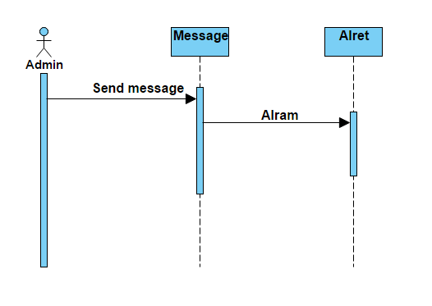

Sequence Diagrams
Select Menu :
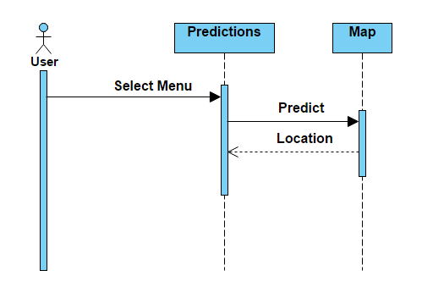

Sequence Diagrams
Information :

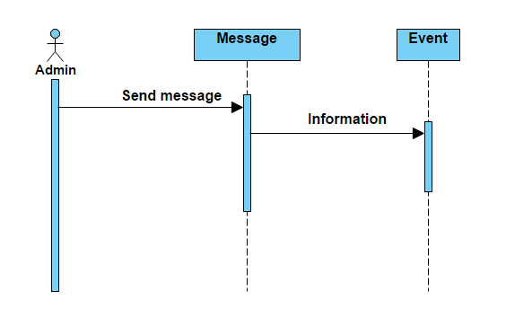

Sequence Diagrams
Logout :
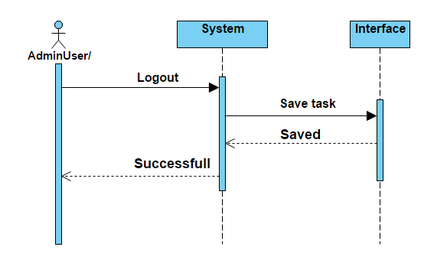

Architecture Design Diagram

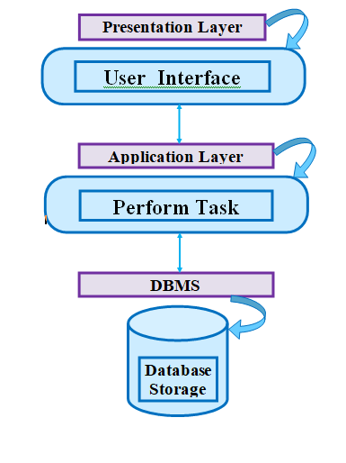

Class Diagram

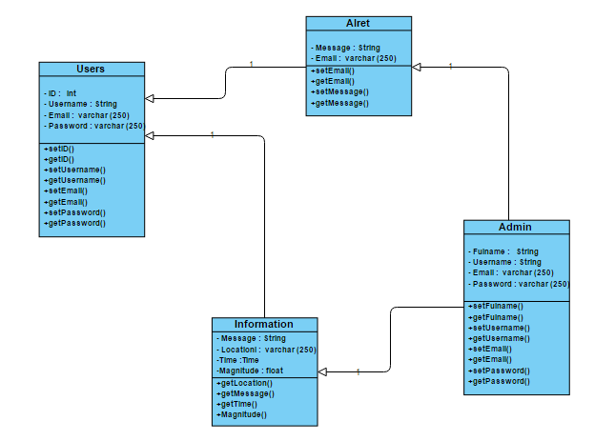

Database Design

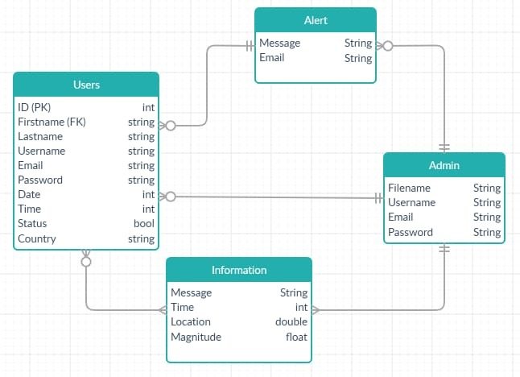

Database Design

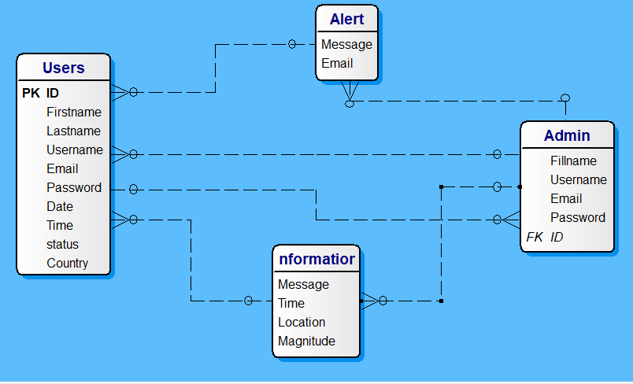

Interface Design

Registration :

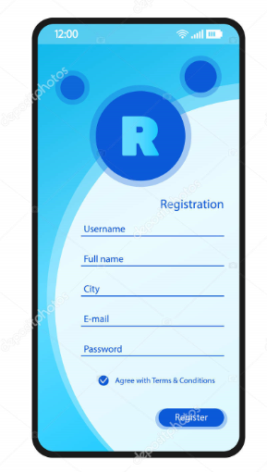

Interface Design

Login :
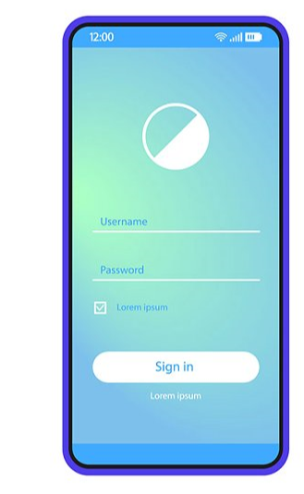

Interface Design

Alert and Prediction :

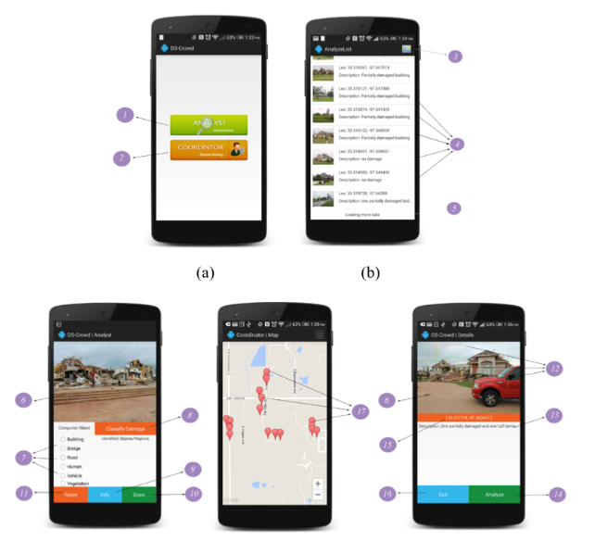

Interface Design

Logout :

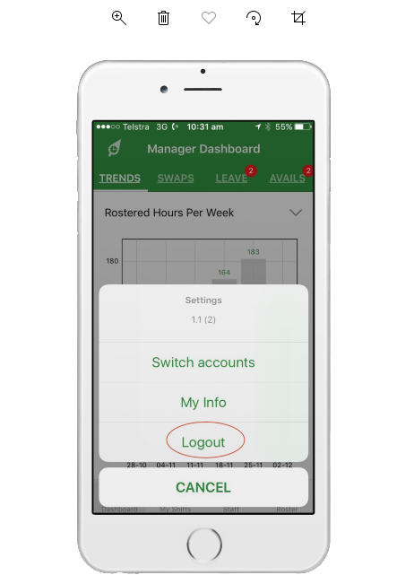

Test Cases

Display Interface of the app registration
S:# | Preconditions | Display Interface of the app registration Administrator and User Must lo be registered and authorized into the running app
1 | Action | User / Administrator Must lo be registered and authorized register on this app after that registration login page appear
2 | Expected Result | App displays a message successful after register
3 | Tested by | F19020601C (MC180403934)
4 | Result | Action Performed Successfully
5 | Authority | User / Admin
6 | Modification History | 1.0
7 | Author | MC180403934
Test Cases

Display Login Interface of the app
S:# | Preconditions | Display Interface of the app Login Administrator and User Must be Login and authorized a valid username and password
1 | Action | User / Administrator Must be Login Administrator will enter user name and password.  Administrator clicks “login”. page appear
2 | Expected Result | App displays a message successful after validation username and password
3 | Tested by | F19020601C (MC180403934)
4 | Result | Action Performed Successfully
5 | Authority | User / Admin
6 | Modification History | 1.0
7 | Author | MC180403934
Test Cases

Alert Message
S:# | Preconditions | User receive alert message (in the form of alarm, email, alert message) .
1 | Action | User receive alert message (in the form of alarm, email, alert message) . User could select from menu of disaster management app ( storms, earthquake, flood and other natural calamities.)
2 | Expected Result | App displays a message successful
3 | Tested by | F19020601C (MC180403934)
4 | Result | Action Performed Successfully
5 | Authority | User / Admin
6 | Modification History | 1.0
7 | Author | MC180403934

Test Cases

Interface to predict location
S:# | Preconditions | Interface to predict location
1 | Action | app show Interface to predict location of the disaster from the map
2 | Expected Result | Prediction of the location
3 | Tested by | F19020601C (MC180403934)
4 | Result | Action Performed Successfully
5 | Authority | User / Admin
6 | Modification History | 1.0
7 | Author | MC180403934

Test Cases

Information of the location
S:# | Preconditions | Information of the location
1 | Action | User get information about the location of event happened about time, magnitude, number of losses, and also possible route and actual location to reach there
2 | Expected Result | Information of the location
3 | Tested by | F19020601C (MC180403934)
4 | Result | Action Performed Successfully
5 | Authority | User / Admin
6 | Modification History | 1.0
7 | Author | MC180403934

Test Cases

Interface to logout
S:# | Preconditions | Interface to logout
1 | Action | User can logout from the system
2 | Expected Result | Logout successfully
3 | Tested by | F19020601C (MC180403934)
4 | Result | Action Performed Successfully
5 | Authority | User / Admin
6 | Modification History | 1.0
7 | Author | MC180403934

___________ ****** The End ****** ___________

